**Project Plan**

***DaClothes***

*Fontys*

|  |
| --- |
| **Date : 22.09.2023** |
| **Version : 1.0** |
| **State : Finished** |
| **Author : Rodrigo Bedoya** |

#### Version history

|  |  |  |  |  |
| --- | --- | --- | --- | --- |
| **Version** | **Date** | **Author(s)** | **Changes** | **State** |
| 1.o | 22.09.2023 | Rodrigo Bedoya | - | Finished |
|  |  |  |  |  |
|  |  |  |  |  |

Contents

1. Project assignment 3

1.1 Context 3

1.2 Goal of the project 3

1.3 Scope and preconditions 3

1.4 Strategy 3

1.5 Research questions and methodology 3

1.6 End products 3

2. Project organization 5

2.1 Stakeholders and team members 5

2.2 Communication 5

3. Activities and time plan 6

3.1 Phases of the project 6

3.2 Time plan and milestones 6

4. Testing strategy and configuration management 7

4.1 Testing strategy 7

4.2 Configuration management 7

5. Finances and risk 8

5.1 Project budget 8

5.2 Risk and mitigation 8

Some risks that could affect the project are: 8

# Project assignment

## Context

This project is an individual assignment, in which I will work on from September 4, 2023, until January 19, 2024. Fontys University of applied sciences reached me to develop an online marketplace. This was idea of the university, to help students earn money by selling their clothes instead of throwing them away and to help others finding clothes they like for a fair price. Nowadays, there are many web applications like this, but none is exclusive for Fontys students.

## Goal of the project

The goal of the project is to have a working user-friendly marketplace for students to sell and buy clothing items.

Currently they don’t have an application of this kind within the university, but there is a community of students where they sell and buy clothes. Fontys wants to create a web application, that way all students can participate in this in the comfort of their houses.

The advantage of this, is that more people will be able to connect with others, people will earn money and others will find stuff they like. I will develop this web application using React for the front-end, Java Spring Boot for the back end and MySQL for the database.

## Scope and preconditions

|  |  |
| --- | --- |
| **Inside scope:** | **Outside scope:** |
| 1. Product listing, browsing and searching | 1. Manual on how to use the application |
| 1. Shopping cart | 1. Support on future features |
| 1. User registration and Authorization | 1. Payment processing |
| 1. Chatting service | 1. Integration with third party logistics and shipping services |
| 1. Order managing | 1. Delivery methods |

## Strategy

The strategy for this project is to adopt an Agile development methodology to ensure flexibility and adaptability to changing requirements. The project will be divided into 6 sprints of 3 weeks, each focusing on specific features and functionalities.

## Research questions and methodology

Some research I might need in the develop of the project is how to do the chatting service using Websockets and the shopping cart. When I encounter these problems, the research I will conduct might include using google to find multiple solutions and choosing the right approach for my project. I also might use YouTube videos for some more explanation and finally ChatGPT when I need it. I will try to understand the answer before I apply it, so I can learn and become a better programmer. If I don’t, I can always ask a teacher about it.

## End products

The expected end products for this project are:

1. 2 git repositories, 1 for the back end and another for the front end.
2. A fully functional online marketplace accessible via web browsers.
3. User authentication and authorization systems.
4. Product listing and management tools for sellers.
5. Shopping cart and order management features for buyers.
6. Real-time WebSocket functionality (optional, for bidding and messaging).
7. Test reports
8. UI Design
9. UML Class diagram
10. UX final report

**PBS**

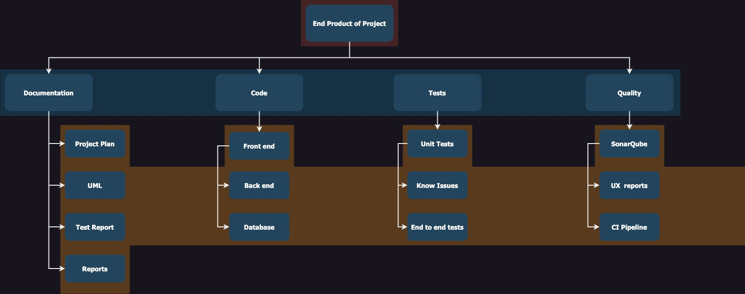

# Project organization

## Stakeholders and team members

|  |  |  |  |
| --- | --- | --- | --- |
| **Name** | **Abbreviation** | **Role and functions** | **Availability** |
| Timo Hermans  [t.hermans@fontys.nl](mailto:t.hermans@fontys.nl) | Timo | Teacher, will help me in any question I have or difficulty I can encounter | Tuesdays and every day through Teams |
| Frank Coenen  [f.coenen@fontys.nl](mailto:f.coenen@fontys.nl) | Frank | Teacher, will help me in any question I have or difficulty I can encounter | Wednesdays and Thursdays and every day through teams |
| Roopali Gupta  [r.gupta@fontys.nl](mailto:r.gupta@fontys.nl) | Roopali | Teacher, will help me in any question I have or difficulty I can encounter | Wednesdays and Thursdays and every day through teams |

## Communication

As the only member of this project, communication is still essential for tracking progress and ensuring alignment with project goals. The following communications methods will be used:

1. Review and Reflection
   * Review project process and identify new challenges and plan the next step.
2. Progress documentation
   * Maintain documentation to track milestones, problems and decisions made through the project.
3. Reports for myself
   * I will summarize achievements, detect the challenges and the upcoming goals.

# Activities and time plan

## Phases of the project

The main phases of the project consist of:

* Sprint 1 – initialization and backend
  + Project plan and documentation
  + Project backlog
  + Backend first steps
* Sprint 2 – Initial frontend setup
  + Design document
  + C4 Model diagram
  + Initial fronted setup: CORS configuration
* Sprint 3 - Initial Backend to Database setup and SonarQube
  + UML Class diagram
  + Backend to database setup
  + SonarQube
* Sprint 4 - Authentication and authorization implementation
  + Finish documents
  + Authentication and Authorization implementation
  + Continuous integration and SonarQube
* Sprint 5 - Websockets feature
  + Final design document
  + Security report
  + WebSockets features
  + Continuous integration and SonarQube
* Sprint 6 – Final delivery
  + Final UX feedback report
  + Final individual track product
  + Continuous integration and SonarQube
  + Continuous Delivery
  + Final delivery

## Time plan and milestones

The sprints are divided in 6 sprints of 3 weeks each, because I only have 18 weeks for this project. I won’t be doing any stand ups, since I am working alone and at the end of the sprint, I will do some retrospective to see what I can improve and what I did wrong.

|  |  |  |  |
| --- | --- | --- | --- |
| **Phasing** | **Effort** | **Start date** | **Finish date** |
| 1. Product listing and Browsing | 15 | Week 4 | Week 6 |
| 1. Product details | 15 | Week 7 | Week 9 |
| 1. Shopping cart and order management | 20 | Week 10 | Week 12 |
| 1. Users messaging | 25 | Week 13 | Week 15 |
| 1. User Authorization and authentication | 25 | Week 16 | Week 18 |

# Testing strategy and configuration management

## Testing strategy

To confirm the quality and reliability of the “DaClothes”, a testing strategy must be employed. At this moment of the project, I don’t know which testing strategy will be used. I know I will use a testing setup called SonarQube.

## Configuration management

I will have two repositories on GitLab, one for the front end and one for the back end, with pipelines.

# Finances and risk

## Project budget

There is no specific budget for this project. However, it is important to identify the necessary resources and requirements to finish the project.

1. Software tools
2. Hardware for the development
3. Internet
4. Documentation and presentation
5. Testing tools

## Risk and mitigation

## Some risks that could affect the project are:

|  |  |  |
| --- | --- | --- |
| **Risk** | **Prevention activities** | **Mitigation activities** |
| 1. Technical challenge | Identify potential challenges and research the technology | Separate time to solve problems. Seek help from teachers or other students. |
| 1. Time management | Follow the deadline on the time plan and milestones. | Prioritize most difficult tasks. If for some reason I get a delay, I will adjust the schedule. |
| 1. Sickness | Balance between life and work and maintain a heathy life. |  |
| 1. Teacher absence | Have a backup communication method, like email or teams and maintain regular communication | Prepare question or small presentations on the progress for a weekly basis. |